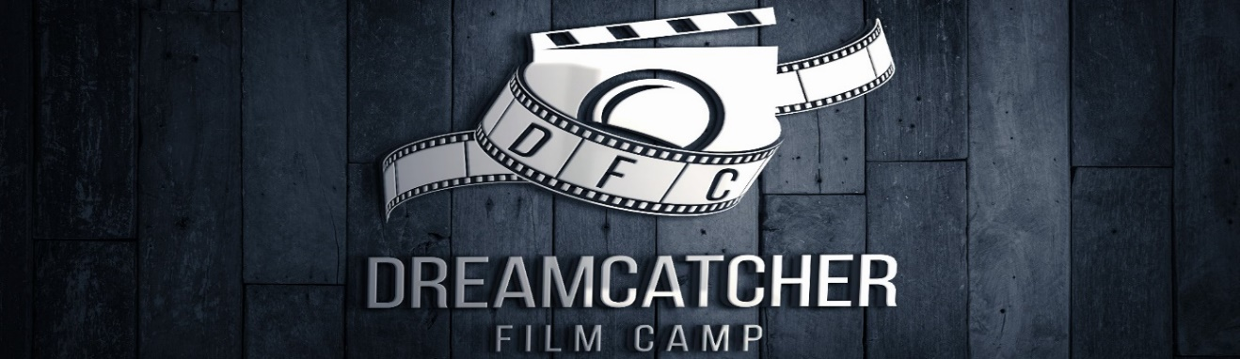

DRCM FILM & TV CAMP 2021

BOOKING FORM / EMERGENCY CONTACT DETAILS / MEDICAL DETAILS

Your booking has been confirmed but please complete the following details for our information during the course period.

DETAILS OF PARTICIPANT

First Name: _____________________________

Surname: ______________________________

Age: _____

School attended (Name and address) ______________________________________

Please indicate dates booked: From to inclusive

CONTACT DETAILS OF PARENT/GUARDIAN

First Name:____________________ Surname:______________________

Address:__________________

Home tel. number: ___________________

PostCode:__________________________

Mobile number: ___________________ E-mail: ___________________________

Please indicate if student has any medical conditions*, allergies, learning or physical disabilities:

*DRCM does not take responsibility for students ingesting foods they are intolerant of or for coming into contact with materials they may be allergic to. Responsibility for the administration of required medicines rests with students themselves and/or their parents. However, it is useful for us to know students’ needs in these matters.
EMERGENCY CONTACTS DURING TRAINING PERIOD (if different from parent details above)

Full Name (print)_______________________ Relationship to child_____________

Telephone no_______________________ Mobile no_____________________

FIRST AID

Permission given for the administering of emergency first aid by qualified first aider (please tick)

YES NO

*Note: If neither box is ticked, it will be assumed permission is not granted

COURSE TIMES AND VENUE INFORMATION
The venue is Elstree Film studios, Shenley Road Borehamwood, Hertfordshire WD6 1JG. Courses run from 9.30am to 2.30pm. DRCM will not be responsible for students outside these hours. It is suggested that students bring a packed lunch although there is a café on site.

Terms and conditions:
DRCM does not accept responsibility for items or valuables lost or stolen while attending DRCM courses. We accept the right to expel any participants due to unacceptable behaviour. Course participants may be taken outside of training venue under supervision for purposes of filming, reconnaissance, rehearsal or to visit working studios. DRCM retains right to alter course dates, venues and syllabus. DRCM owns the copyright of, and reserves the right to exhibit, all or part of films, programmes and any other course content made in association with them at DRCM screening events and at cinemas, schools, film festivals, broadcast TV and relevant websites. To the extent where any copyright may not vest in DRCM you hereby assign such rights to DRCM for the full period of copyright including any renewals and extensions. DRCM may also use photographs from workshops and screenings for promotional use including online and electronic promotion. Parents will be informed if photographs or moving images of their child/children are being used for promotional purposes. Please note for illustration purposes films with a PG certificate (e.g. ET, Home Alone) may be viewed in class under the supervision of adult tutors. Please inform us if this is not acceptable. Cancellations: For bookings cancelled more than 6 weeks in advance of start date - full refund; cancelled between 4-6 weeks – 75% refund; cancelled between 2-4 weeks - 50% refund; less than 2 weeks – no refund. Data: DRCM will not pass on any information provided on this form to third parties but may use it for its own marketing. Please tick here if you are willing to receive further information about DRCM courses

By signing below, I agree to the Terms and Conditions

Parent/Guardian Signature_________________________________ Date_____________

Print Name_____________________________________________________

